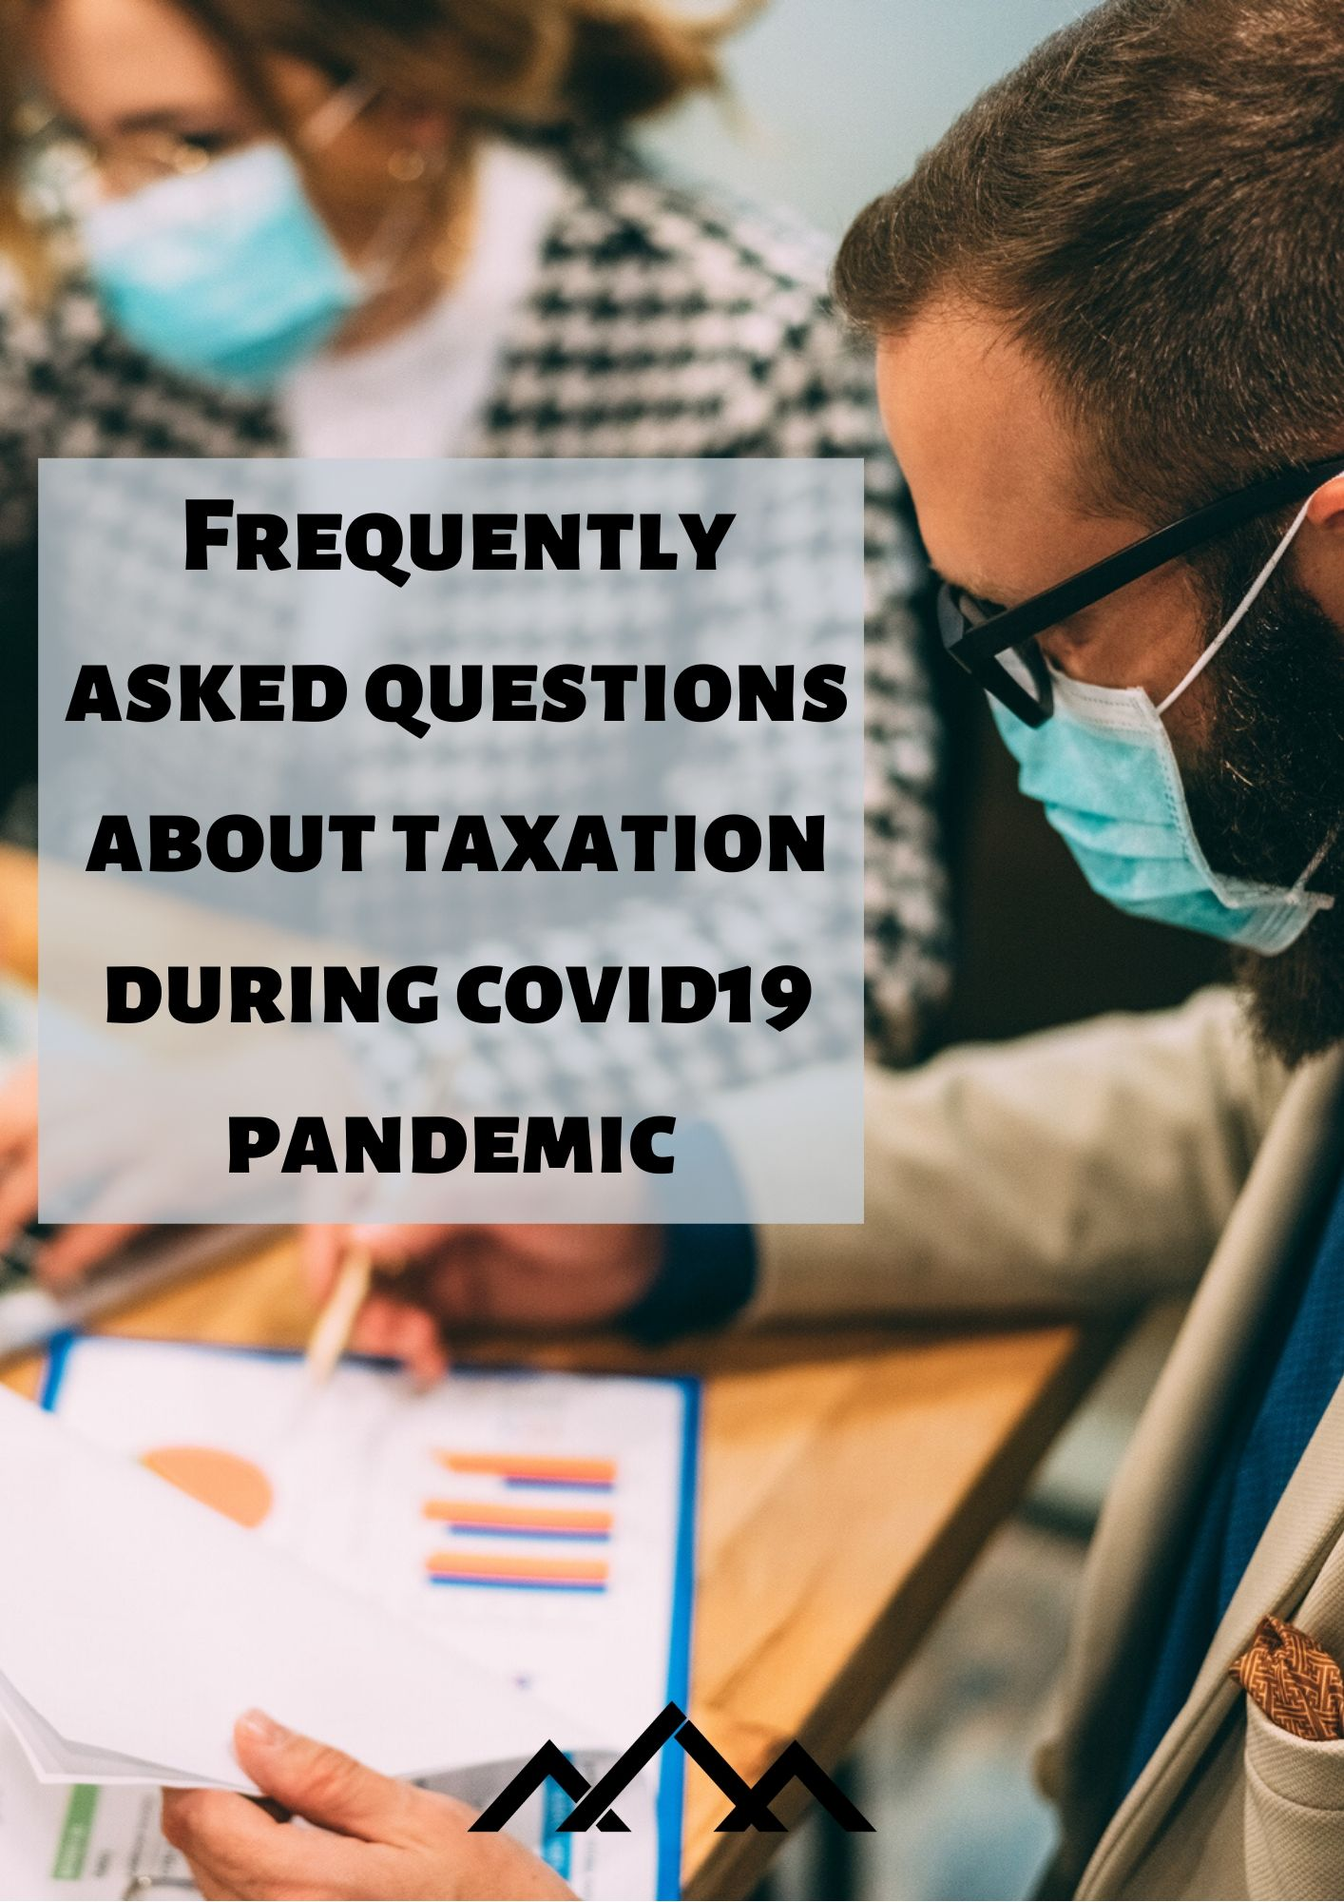

I. ANNUAL ASSESSMENT OF PERSONAL INCOME TAX 3
1. Is there any change in the field of the annual assessment of personal income tax due to the coronavirus pandemic? 3
2. What will be the change in connection with the annual assessment of personal income tax for natural persons with business activities (other than persons entitled to a flat rate deduction)? 3
3. Do natural persons with business activities, who establish the tax base on the basis of norm expenditures (persons entitled to a flat rate deduction) receive their own informative calculations of personal income tax? 4
II. RUNNING OF TIME LIMITS FOR PERFORMING PROCEDURAL ACTIONS OF TAXABLE PERSONS 4
4. Are time limits of procedural actions, e.g. time limits for appeals, objections, filing of various tax returns, etc. interrupted due to the coronavirus pandemic? 4
5. Are due to the coronavirus pandemic time limits interrupted for payment of obligations (e.g. payment of personal income tax, compensation for the use of building land, etc.)? 5
6. Which contributions are paid by entitled employers and for which the exemption is in force? 5
7. Due to the coronavirus pandemic I cannot file a tax return. Can I file it after the end of the pandemic? 5
8. Are during the coronavirus pandemic the time limits or obligations of taxable persons in FURS audits changed (e.g. in audit procedures)? 5
9. Will be tax assessed later due to the coronavirus pandemic (e.g. real property transaction tax or tax on motor vehicles)? 5
III. VAT REFUND TO TAXABLE PERSONS NOT ESTABLISHED IN SLOVENIA 5
10. Will your office consider accepting electronically signed Letters of authority e.g. signed via DocuSign? 6
11. Will you consider extending the forthcoming June deadline for 13th Directive applications? 6
12. If the June deadline (30. 6. 2020) is not planned to be extended will your office consider accepting June deadline applications via e-mail where only scanned copies of all required documents (Invoices, Certificates and Letters of authority) are provided? Will you consider such applications as submitted within the legislative deadline? 6
13. In terms of deadlines for answering Requests for additional information or submitting Appeals will you consider a more flexi approach in this regard where claimants are not in position to provide documents or information within the set deadlines? 6
IV. DWFERRAL OF VAT MOSS PAYMENTS AND TAX RELIEFS IN SLOVENIA 6
14. Will you consider extending the forthcoming April deadline for submission and corresponding payment for VAT return Q12020 (January-March)? 7

ANNUAL ASSESSMENT OF PERSONAL INCOME TAX

1. Is there any change in the field of the annual assessment of personal income tax due to the coronavirus pandemic?
FURS issues informative calculations of personal income tax for 2019 to natural persons who don’t perform business activities within similar time limits as in previous years – the first set on 31. 3. 2020, the second set is planned for 29. 5. 2020, and an additional third set will be issued on 30. 6. 2020.
In the first set only those taxable persons have received informative calculations of personal income tax for 2019, who don’t perform business activities and receive refund of personal income tax, taxable persons without refund or additional payment (zero) and taxable persons with an additional payment up to 2€, which is written off in accordance with Article 277 of the ZDavP-2 at the annual settlement of personal income tax. Taxable persons with the additional payment of personal income tax have not received informative calculations of personal income tax in the first set. It is planned that those persons will receive informative calculations of personal income tax in the next set. Time limits for objections, refunds and additional payments shall not be changed although the time limits are set additionally within the realisation of the additional third set of informative calculations of personal income tax for 2019.
Due to the extension of the time limit for submission of the annual settlement of DohDej for 2019, which is postponed from 31. 3. 2020 to 31. 5. 2020, those taxable persons and possible remaining individual taxable persons, on whom the data from DohDej settlements consequently influence, will receive the informative calculation of personal income tax for 2019 in the third set that is until the end of June 2020.
In connection with the change in the time limit for issuing informative calculations of personal income tax for 2019, the time limit is also postponed, which determines the obligation of filing the return for assessment of personal income tax for 2019 from 31. 7. 2020 to 31. 8. 2020 if by the time limit set the taxable person that is a resident doesn’t receive an informative calculation of personal income tax. The stated time limit is postponed from 15 June to 15 July 2020. This means that if the informative calculation of personal income tax for 2019 has not been served to the taxable person by 15 July 2020, this person shall file a return for assessment of personal income tax by 31 August 2020.

2. What will be the change in connection with the annual assessment of personal income tax for natural persons with business activities (other than persons entitled to a flat rate deduction)?
Natural persons with business activities (other than persons entitled to a flat rate deduction) will in accordance with the changed situation receive their informative calculations a month later than in previous years, which means until the end of June. In accordance with this changed circumstances all time limits, which are linked to the date of issuing the informative calculation of personal income tax, are postponed for one month (the time limit for objection until the end of July, the time limit for refund and additional payment of personal income tax until the end of August). The reason for postponing the time limit for issuing the informative calculation of personal income tax for natural persons with business activities is the postponement of time limits for submission of their annual DohDej settlements, on the basis of which informative calculations are created.

3. Do natural persons with business activities, who establish the tax base on the basis of norm expenditures (persons entitled to a flat rate deduction) receive their own informative calculations of personal income tax?
No if that is their only income liable for personal income tax. If in the preceding year they received also incomes, which are included in the annual tax base for assessment of personal income tax, they will receive the informative calculation of personal income tax, which will include those incomes. Although this is not a consequence of intervention measures because also in the previous years those incomes from business activities were not included in the annual assessment of personal income tax for persons entitled to a flat rate deduction. That means that those persons have only incomes from business activities and they are not liable for annual assessment and they don’t receive informative calculations for personal income tax.

II. RUNNING OF TIME LIMITS FOR PERFORMING PROCEDURAL ACTIONS OF TAXABLE PERSONS

4. Are time limits of procedural actions, e.g. time limits for appeals, objections, filing of various tax returns, etc. interrupted due to the coronavirus pandemic?
Running of time limits depends on the fact whether this is an urgent matter as defined by the Act on temporary measures in connection with judicial, administrative and other public matters for managing the spreading of infectious disease SARS-CoV-2 (COVID-19) – ZZUSUDJZ (Official Gazette of the Republic of Slovenia, no. 36/20). This means:
- In urgent matters (e.g. procedures of tax assessment, customs procedures, submission of returns, procedures of write-off, postponement and payment in instalments, stopping or suspension of tax enforcement, etc.) TIME LIMITS RUN, which means that taxable persons shall meet their obligations or fulfil the right or claim within the time limit (e.g. supplement the application, pay tax, file an appeal, etc.).
- In matters which are not urgent (e.g. as a rule, urgent procedures are not those in connection with subsequent supervision in accordance with Articles 129 and 130 of the ZDavP-2, audit procedures, offence procedures, decision-making about the payment in instalments of offence obligations in accordance with Article 18 of the ZP-1, etc.) TIME LIMITS DO NOT RUN, which means that taxable persons may meet their obligations or fulfil the rights or claim after the cessation of measures (e.g. supplement the application, pay tax, file an appeal, etc.).

At this point it has to be emphasized that in accordance with paragraph one of Article 7 of the ZZUSUDJZ it is not allowed to file applications in writing and in oral procedure, e.g. appeals, objections and various tax returns directly with the authority. With the purpose to avoid unnecessary contacts the taxable persons have a possibility to file various applications (appeals, objections or returns) as follows:
- in electronic form: via eDavki portal or mobile application,
- in electronic form: without the secure electronic signature (in this case the officially assigned identification number shall be stated in the application that is a personal registration number or tax number of the taxable person) and
- via post office mail.

More detailed explanations in connection with running of time limits (and other measures) are published on FURS website.

5. Are due to the coronavirus pandemic time limits interrupted for payment of obligations (e.g. payment of personal income tax, compensation for the use of building land, etc.)?
As a rule, no. See the reply at question 6.

6. Which contributions are paid by entitled employers and for which the exemption is in force?
The exemption of payment of contributions shall refer to salaries paid for work in the period of pandemic that is for March (from 13.3. to 31.3.), April and May 2020. Contributions for pension and disability insurance (employee and employer) are exempt from payment and the employer shall only settle them, other contributions shall be paid in whole.

7. Due to the coronavirus pandemic I cannot file a tax return. Can I file it after the end of the pandemic?
No. The return shall be filed within the prescribed time limit.
With the purpose to avoid unnecessary contacts, the taxable persons have a possibility to file returns:
- in electronic form: via eDavki portal or a mobile application,
- in electronic form: without the secure electronic signature (in this case the officially assigned identification number that is a personal registration number or tax number of the taxable person shall be stated on the application) and
- via regular mail.
More detailed explanations in connection with filing applications during the period when intervention measures are in force are published on FURS website.

8. Are during the coronavirus pandemic the time limits or obligations of taxable persons in FURS audits changed (e.g. in audit procedures)?
In cases of performing procedures of subsequent supervision (e.g. tax audit supervision), which are not urgent, as a rule, the rules are in force referred to in paragraphs one and two of Article 6 of the Act on temporary measures in connection with judicial, administrative and other public matters for managing the spreading of infectious disease SARS-CoV-2 (COVID-19). This means that during the period when the extraordinary measures are in force the procedural and material time limits shall not run. This means that during this period the interest shall not run, which is charged in accordance with Article 95 of the Tax Procedure Act.

More detailed explanations in connection with temporary measures in audit matters are published on FURS website.

9. Will be tax assessed later due to the coronavirus pandemic (e.g. real property transaction tax or tax on motor vehicles)?
The Financial Administration of the Republic of Slovenia will continue its efforts to perform all assessment procedures in the shortest time possible without extending the time limits for assessment due to the coronavirus pandemic.

III. VAT REFUND TO TAXABLE PERSONS NOT ESTABLISHED IN SLOVENIA

10. Will your office consider accepting electronically signed Letters of authority e.g. signed via DocuSign?
Yes. An electronic signature is a legally acceptible tool for execution of a document (including a deed), provided that the signatory intends to authenticate the document and that any relevant formalities, such as the signature being witnessed, are satisfied. The Commission’s view is based upon legislation and court decisions, which relate to both non-electronic and electronic signatures.

11. Will you consider extending the forthcoming June deadline for 13th Directive applications?
Slovenia has not adopted any amendments to VAT legislation based on which the forthcoming June deadline for 13th Directive applications would be extended. If any changes as regards VAT occur, they will be available on our website: https://www.fu.gov.si/en/taxes_and_other_duties/areas_of_work/value_added_tax_vat/.

12. If the June deadline (30. 6. 2020) is not planned to be extended will your office consider accepting June deadline applications via e-mail where only scanned copies of all required documents (Invoices, Certificates and Letters of authority) are provided? Will you consider such applications as submitted within the legislative deadline?
See previous answer (under question 11).
Taxable persons established in a non-EU Member State file their VAT refund claims in Slovenia via the eDavki electronic portal by using the form DDV-VTD. Before filing their claims, applicants must obtain a VAT identification number and a qualified digital certificate to access the Financial Administration's electronic eDavki system.
Taxable persons may attach copies of invoices to their claims on the basis of which a VAT refund is claimed in Slovenia and an authorisation for representation if they are represented by an authorised person. The maximum size of the attached documents shall not exceed 5 Mb. The permitted formats of attachments are pdf, jpeg, tiff and zip. It is recommended that copies should be made and saved in a file in advance since the attachment should be made to the claim itself and not sent separately as own document.

13. In terms of deadlines for answering Requests for additional information or submitting Appeals will you consider a more flexi approach in this regard where claimants are not in position to provide documents or information within the set deadlines?
If a tax officer sends a request for additional information, and the claimants will not be able to response within the time limit set, they can apply for extension of the time limit.
Running of time limits depends on the fact whether this is an urgent matter as defined by the Act on temporary measures in connection with judicial, administrative and other public matters for managing the spreading of infectious disease SARS-CoV-2 (COVID-19) – ZZUSUDJZ (Official Gazette of the Republic of Slovenia, no. 36/20). See answer under question 4.

IV. DEFERRAL OF VAT MOSS PAYMENTS AND TAX RELIEFS IN SLOVENIA

14. Will you consider extending the forthcoming April deadline for submission and corresponding payment for VAT return Q12020 (January-March)?
Slovenia has not adopted any amendments to VAT legislation on the basis of which the deadline to submit MOSS VAT returns and corresponding payments could be deferred.
If any changes in respect of VAT occur, they will be available on FURS website: https://www.fu.gov.si/en/taxes_and_other_duties/areas_of_work/value_added_tax_vat/.
During the coronavirus pandemic, the payment benefits for business entities are defined by the Act on intervention measures in the fiscal area (hereinafter: ZIUJP). On the basis of the ZIUJP the tax authority may, notwithstanding the conditions referred to in paragraph one of Article 102 of the Tax Procedure Act - ZDavP-2, permit deferral of tax payment for the period up to two years or tax payment in maximum 24 monthly instalments in the period of 24 months due to the loss of capability of earning incomes due to the pandemic (paragraph one of Article 7 of the ZIUJP).
The taxable person shall file an application for deferral or paying tax in instalments with the tax authority, via regular mail or using a financial office electronic address where the taxable person is entered in the tax register or via eDavki (eTaxes) portal (where a handwritten signature of the taxable person in the application is not necessary). A special form is created for submission of the application on the basis of the ZIUJP, which is published on FURS website (go to: https://edavki.durs.si/EdavkiPortal/OpenPortal/CommonPages/Opdynp/PageD.aspx?category=odlog_obrok_epidemija_virus_covid19_po), where in addition to the application form there are also detailed explanations where and how the application is filed.

